Simple Oval Track Details

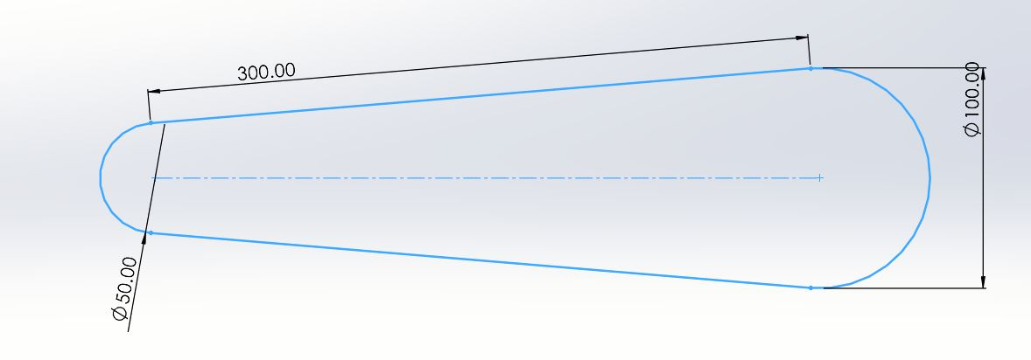

Total Length: 839.78m

Sections: 83x10m + 1x9.78m

1. Take a